Folder Structure:
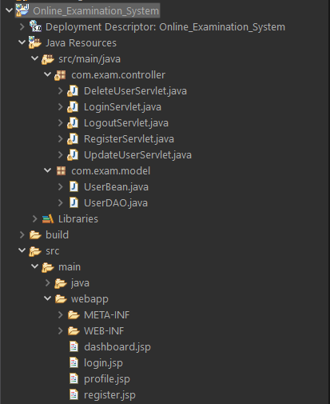
Login.jsp
<%@ page language="java" contentType="text/html; charset=ISO-8859-1"
pageEncoding="ISO-8859-1"%>
<!DOCTYPE html>
<html>
<head>
<title>User Login - Online Examination System</title>
<style>
body {
font-family: 'Segoe UI', Tahoma, Geneva, Verdana, sans-serif;
background-color: #f0f4f8;
margin: 0;
padding: 0;
}

h2 {
text-align: center;
padding: 20px;
background-color: #2e8bcb;
color: white;
margin: 0;
}

.container {
max-width: 400px;
margin: 50px auto;
background-color: #ffffff;
padding: 30px 40px;
border-radius: 10px;
box-shadow: 0 0 10px rgba(0,0,0,0.1);
}

.form-field {
margin-bottom: 20px;
display: flex;
flex-direction: column;
}

.form-field label {
margin-bottom: 6px;
font-weight: 500;
}

.form-field input[type="text"],
.form-field input[type="password"] {
padding: 10px;
font-size: 14px;
border: 1px solid #ccc;
border-radius: 6px;
}

.submit-btn {
width: 100%;
padding: 12px;
font-size: 16px;
border: none;
background-color: #2e8bcb;
color: white;
border-radius: 6px;
cursor: pointer;
transition: background 0.3s;
}

.submit-btn:hover {
background-color: #1f6ea5;
}

.link {
text-align: center;
margin-top: 20px;
}

.link a {
color: #2e8bcb;
text-decoration: none;
}

.link a:hover {
text-decoration: underline;
}

.error-message {
color: red;
text-align: center;
margin-top: 15px;
font-weight: bold;
}
</style>
</head>
<body>

<h2>User Login - Online Examination</h2>

<div class="container">
<form method="post" action="LoginServlet">
<div class="form-field">
<label>Registration Number:</label>
<input type="text" name="registrationNumber" required />
</div>

<div class="form-field">
<label>Login Name:</label>
<input type="text" name="loginName" required />
</div>

<div class="form-field">
<label>Password:</label>
<input type="password" name="password" required />
</div>

<input type="submit" value="Login" class="submit-btn" />
</form>

<div class="link">
<p>New user? <a href="register.jsp">Register here</a></p>
</div>

<% if (request.getParameter("error") != null) { %>
<div class="error-message">Invalid login. Please try again.</div>
<% } %>
</div>

</body>
</html>

LoginServlet.java
package com.exam.controller;

import com.exam.model.UserBean;
import com.exam.model.UserDAO;

import jakarta.servlet.ServletException;
import jakarta.servlet.annotation.WebServlet;
import jakarta.servlet.http.HttpServlet;
import jakarta.servlet.http.HttpServletRequest;
import jakarta.servlet.http.HttpServletResponse;
import jakarta.servlet.http.HttpSession;

import java.io.IOException;

public class LoginServlet extends HttpServlet {
protected void doPost(HttpServletRequest req, HttpServletResponse res) throws ServletException, IOException {

String regNo = req.getParameter("registrationNumber");
String loginName = req.getParameter("loginName");
String password = req.getParameter("password");

UserDAO dao = new UserDAO();
UserBean user = dao.validateUser(regNo, loginName, password);

if (user != null) {
HttpSession session = req.getSession();
session.setAttribute("user", user);
res.sendRedirect("dashboard.jsp");
} else {
res.sendRedirect("login.jsp?error=1");
}
}
}

Login Page:
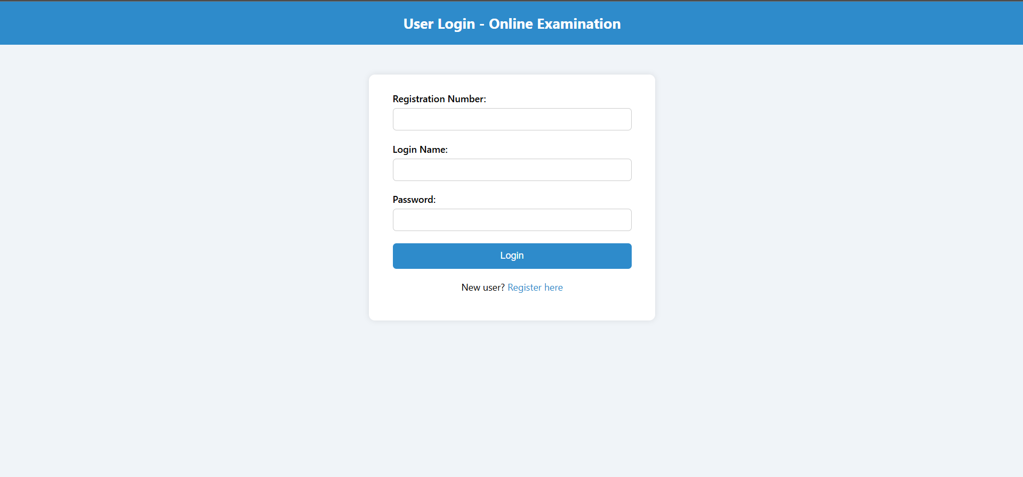
Register.jsp
<%@ page language="java" contentType="text/html; charset=ISO-8859-1"
pageEncoding="ISO-8859-1"%>
<!DOCTYPE html>
<html>
<head>
<title>Register - Online Examination System</title>
<style>
body {
font-family: 'Segoe UI', Tahoma, Geneva, Verdana, sans-serif;
background-color: #f0f4f8;
margin: 0;
padding: 0;
}

h2 {
text-align: center;
padding: 20px;
background-color: #2e8bcb;
color: white;
margin: 0;
}

.container {
max-width: 900px;
width: 95%;
margin: 30px auto;
background-color: #ffffff;
padding: 30px 40px;
border-radius: 10px;
box-shadow: 0 0 10px rgba(0,0,0,0.1);
}

.form-grid {
display: grid;
grid-template-columns: 1fr 1fr;
gap: 20px;
}

.form-field {
display: flex;
flex-direction: column;
}

.form-field label {
margin-bottom: 6px;
font-weight: 500;
}

.form-field input[type="text"],
.form-field input[type="password"],
.form-field select {
padding: 10px;
font-size: 14px;
border: 1px solid #ccc;
border-radius: 6px;
}

.full-width {
grid-column: 1 / -1;
}

.registration-number {
font-weight: bold;
font-size: 18px;
color: #256e9f;
}

.buttons {
display: flex;
justify-content: space-between;
margin-top: 20px;
}

.buttons input {
flex: 1;
margin: 0 5px;
padding: 12px;
font-size: 16px;
border: none;
background-color: #2e8bcb;
color: white;
border-radius: 6px;
cursor: pointer;
transition: background 0.3s;
}

.buttons input:hover {
background-color: #1f6ea5;
}

.error-message {
color: red;
text-align: center;
margin-top: 10px;
font-weight: bold;
}

.link {
text-align: center;
margin-top: 20px;
}

.link a {
color: #2e8bcb;
text-decoration: none;
}

.link a:hover {
text-decoration: underline;
}

@media screen and (max-width: 768px) {
.form-grid {
grid-template-columns: 1fr;
}
.buttons {
flex-direction: column;
gap: 10px;
}
}
</style>

<script>
function clearForm() {
document.getElementById("registerForm").reset();
generateRegNo();
}

function generateRegNo() {
const letters = "ABCDEFGHIJKLMNOPQRSTUVWXYZ";
let regNo = "";
for (let i = 0; i < 4; i++) {
regNo += letters.charAt(Math.floor(Math.random() * letters.length));
}
for (let i = 0; i < 7; i++) {
regNo += Math.floor(Math.random() * 10);
}
document.getElementById("regText").innerText = regNo;
document.getElementById("regHidden").value = regNo;
}

window.onload = generateRegNo;
</script>
</head>
<body>

<h2>User Registration - Online Examination</h2>

<div class="container">
<form id="registerForm" method="post" action="RegisterServlet">
<div class="form-grid">
<div class="form-field full-width">
<label>Registration Number: <span id="regText" class="registration-number"></span></label>
<input type="hidden" name="registrationNumber" id="regHidden" />
</div>

<div class="form-field">
<label>First Name:</label>
<input type="text" name="firstName" required />
</div>

<div class="form-field">
<label>Middle Name:</label>
<input type="text" name="middleName" required />
</div>

<div class="form-field">
<label>Last Name:</label>
<input type="text" name="lastName" required />
</div>

<div class="form-field">
<label>Date of Birth (dd-mm-yyyy):</label>
<input type="text" name="DOB" required />
</div>

<div class="form-field">
<label>Sex:</label>
<select name="sex" required>
<option value="">--Select--</option>
<option value="Male">Male</option>
<option value="Female">Female</option>
<option value="Other">Other</option>
</select>
</div>

<div class="form-field">
<label>Email ID:</label>
<input type="text" name="emailID" required />
</div>

<div class="form-field">
<label>Phone Number:</label>
<input type="text" name="phoneNumber" required />
</div>

<div class="form-field">
<label>House Number:</label>
<input type="text" name="houseNumber" required />
</div>

<div class="form-field">
<label>Street:</label>
<input type="text" name="street" required />
</div>

<div class="form-field">
<label>City:</label>
<input type="text" name="city" required />
</div>

<div class="form-field">
<label>State:</label>
<input type="text" name="state" required />
</div>

<div class="form-field">
<label>Country:</label>
<input type="text" name="country" required />
</div>

<div class="form-field">
<label>Pincode:</label>
<input type="text" name="pincode" required />
</div>

<div class="form-field">
<label>Login Name:</label>
<input type="text" name="loginName" required />
</div>

<div class="form-field">
<label>Password:</label>
<input type="password" name="password" required />
</div>
</div>

<div class="buttons">
<input type="submit" value="Continue" />
<input type="button" value="Clear" onclick="clearForm()" />
</div>

<div class="link">
<p>Already have an account? <a href="login.jsp">Login here</a></p>
</div>

<% if (request.getParameter("error") != null) { %>
<div class="error-message">Registration failed. Try again.</div>
<% } %>
</form>
</div>

</body>
</html>

RegisterServlet.java
package com.exam.controller;

import com.exam.model.UserBean;
import com.exam.model.UserDAO;
import jakarta.servlet.ServletException;
import jakarta.servlet.http.HttpServlet;
import jakarta.servlet.http.HttpServletRequest;
import jakarta.servlet.http.HttpServletResponse;

import java.io.IOException;
import java.util.Random;

public class RegisterServlet extends HttpServlet {
protected void doPost(HttpServletRequest req, HttpServletResponse res) throws ServletException, IOException {

String regNo = generateRegistrationNumber();

String firstName = req.getParameter("firstName");
String middleName = req.getParameter("middleName");
String lastName = req.getParameter("lastName");
String dob = req.getParameter("DOB");
String sex = req.getParameter("sex");
String emailID = req.getParameter("emailID");

String houseNumber = req.getParameter("houseNumber");
String street = req.getParameter("street");
String city = req.getParameter("city");
String state = req.getParameter("state");
String country = req.getParameter("country");
String pincode = req.getParameter("pincode");

String phoneNumber = req.getParameter("phoneNumber");
String loginName = req.getParameter("loginName");
String password = req.getParameter("password");

UserBean user = new UserBean();
user.setRegistrationNumber(regNo);
user.setFirstName(firstName);
user.setMiddleName(middleName);
user.setLastName(lastName);
user.setDOB(dob);
user.setSex(sex);
user.setEmailID(emailID);
user.setHouseNumber(houseNumber);
user.setStreet(street);
user.setCity(city);
user.setState(state);
user.setCountry(country);
user.setPincode(pincode);
user.setPhoneNumber(phoneNumber);
user.setLoginName(loginName);
user.setPassword(password);

UserDAO dao = new UserDAO();
if (dao.registerUser(user)) {
res.sendRedirect("login.jsp");
} else {
res.sendRedirect("register.jsp?error=1");
}
}

private String generateRegistrationNumber() {
String letters = "ABCDEFGHIJKLMNOPQRSTUVWXYZ";
StringBuilder regNo = new StringBuilder();

Random random = new Random();

for (int i = 0; i < 4; i++) {
regNo.append(letters.charAt(random.nextInt(letters.length())));
}

for (int i = 0; i < 7; i++) {
regNo.append(random.nextInt(10));
}
return regNo.toString();
}
}

Registration Page:
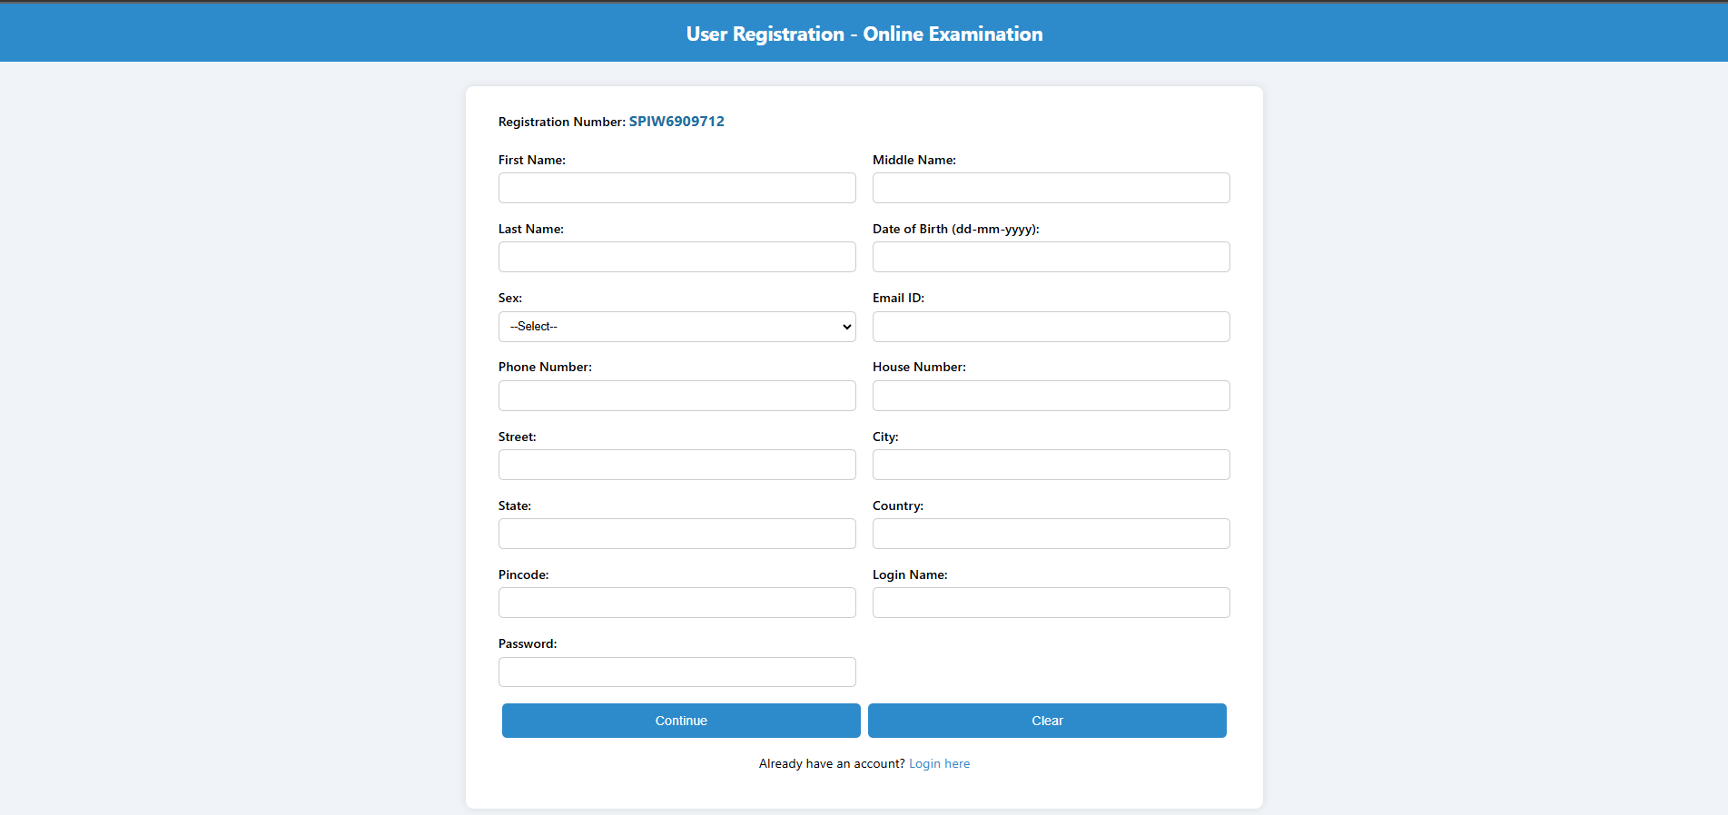

Dashboard.jsp
<%@ page import="com.exam.model.UserBean" %>
<%@ page session="true" %>
<%
UserBean user = (UserBean) session.getAttribute("user");
if (user == null) {
response.sendRedirect("login.jsp");
return;
}
%>
<!DOCTYPE html>
<html>
<head>
<title>User Dashboard - Online Examination System</title>
<style>
body {
font-family: 'Segoe UI', Tahoma, Geneva, Verdana, sans-serif;
background-color: #f0f4f8;
margin: 0;
padding: 0;
}

.navbar {
background-color: #2e8bcb;
color: white;
padding: 20px 40px;
display: flex;
justify-content: space-between;
align-items: center;
flex-wrap: wrap;
}

.user-info {
font-size: 18px;
font-weight: 500;
}

.actions form {
display: inline-block;
margin-left: 10px;
}

.actions button {
padding: 10px 16px;
font-size: 14px;
border: none;
border-radius: 6px;
background-color: #ffffff;
color: #2e8bcb;
font-weight: bold;
cursor: pointer;
transition: all 0.3s ease;
}

.actions button:hover {
background-color: #1f6ea5;
color: white;
}

.welcome {
margin-top: 80px;
text-align: center;
font-size: 24px;
color: #333333;
}

@media (max-width: 768px) {
.navbar {
flex-direction: column;
align-items: flex-start;
gap: 10px;
}

.actions {
margin-top: 10px;
}

.actions form {
margin-left: 0;
margin-top: 5px;
}
}
</style>
</head>
<body>

<div class="navbar">
<div class="user-info">
Welcome, <strong><%= user.getFirstName() %> <%= user.getLastName() %></strong>
(Reg No: <%= user.getRegistrationNumber() %>)
</div>
<div class="actions">
<form action="profile.jsp" method="get">
<button type="submit">Profile</button>
</form>
<form action="DeleteUserServlet" method="post">
<input type="hidden" name="registrationNumber" value="<%= user.getRegistrationNumber() %>" />
<button type="submit">Delete Account</button>
</form>
<form action="LogoutServlet" method="post">
<button type="submit">Logout</button>
</form>
</div>
</div>

<div class="welcome">
<h2>Welcome to the Online Examination System!</h2>
</div>

</body>
</html>

Home page:
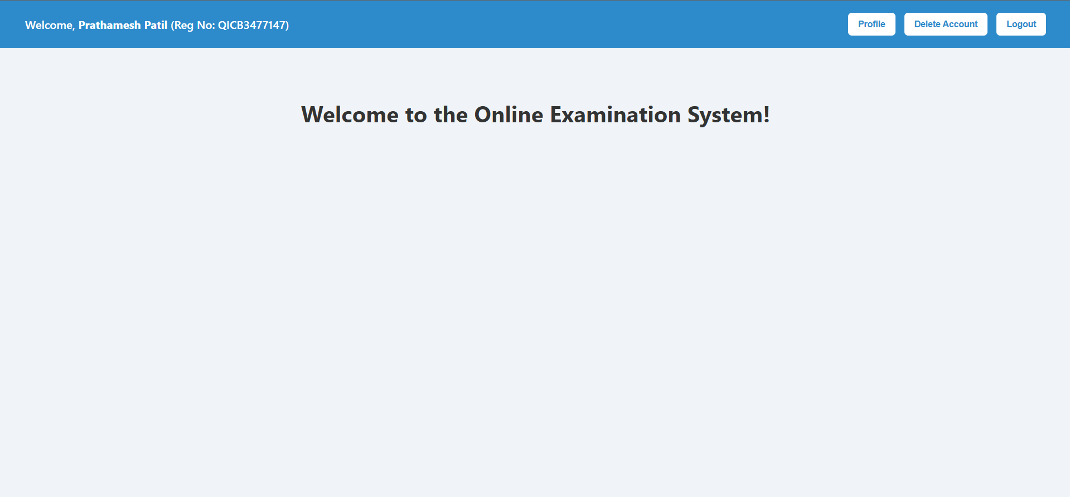

UpdateUserServlet.java
package com.exam.controller;

import com.exam.model.UserBean;
import com.exam.model.UserDAO;

import jakarta.servlet.annotation.WebServlet;
import jakarta.servlet.http.*;
import jakarta.servlet.*;

import java.io.IOException;

public class UpdateUserServlet extends HttpServlet {
protected void doPost(HttpServletRequest req, HttpServletResponse res) throws ServletException, IOException {
UserBean user = new UserBean();

user.setRegistrationNumber(req.getParameter("registrationNumber"));
user.setFirstName(req.getParameter("firstName"));
user.setMiddleName(req.getParameter("middleName"));
user.setLastName(req.getParameter("lastName"));
user.setDOB(req.getParameter("DOB"));
user.setSex(req.getParameter("sex"));
user.setEmailID(req.getParameter("emailID"));
user.setPhoneNumber(req.getParameter("phoneNumber"));
user.setLoginName(req.getParameter("loginName"));
user.setPassword(req.getParameter("password"));

UserDAO dao = new UserDAO();
boolean updated = dao.updateUser(user);

if (updated) {
HttpSession session = req.getSession();
session.setAttribute("user", user);
res.sendRedirect("profile.jsp");
} else {
res.sendRedirect("profile.jsp?error=1");
}
}
}

Profile.jsp
<%@ page import="com.exam.model.UserBean" %>
<%@ page session="true" %>
<%
UserBean user = (UserBean) session.getAttribute("user");
if (user == null) {
response.sendRedirect("login.jsp");
return;
}
%>
<!DOCTYPE html>
<html>
<head>
<title>User Profile - Online Examination System</title>
<style>
body {
font-family: 'Segoe UI', Tahoma, Geneva, Verdana, sans-serif;
background-color: #f0f4f8;
margin: 0;
padding: 0;
}

.container {
max-width: 1000px;
margin: 50px auto;
background-color: #ffffff;
padding: 30px 40px;
border-radius: 10px;
box-shadow: 0 4px 12px rgba(0,0,0,0.1);
}

h2 {
text-align: center;
color: #2e8bcb;
margin-bottom: 30px;
}

.form-grid {
display: grid;
grid-template-columns: 1fr 1fr;
gap: 20px 40px;
}

.form-group {
display: flex;
flex-direction: column;
}

label {
font-weight: 600;
margin-bottom: 5px;
color: #333;
}

input[type="text"],
input[type="email"] {
padding: 10px;
border: 1px solid #ccc;
border-radius: 6px;
background-color: #f9f9f9;
}

input[type="text"]:focus,
input[type="email"]:focus {
border-color: #2e8bcb;
background-color: #ffffff;
outline: none;
}

.full-width {
grid-column: span 2;
}

p {
background-color: #eef6fb;
padding: 10px 15px;
border-radius: 6px;
color: #2c3e50;
}

button {
width: 100%;
padding: 12px;
font-size: 16px;
font-weight: bold;
background-color: #2e8bcb;
color: white;
border: none;
border-radius: 6px;
cursor: pointer;
margin-top: 30px;
transition: background-color 0.3s ease;
}

button:hover {
background-color: #1f6ea5;
}

@media (max-width: 768px) {
.form-grid {
grid-template-columns: 1fr;
}

.full-width {
grid-column: span 1;
}
}
</style>
</head>
<body>

<div class="container">
<h2>User Profile</h2>
<form action="UpdateUserServlet" method="post">
<div class="form-grid">

<div class="form-group full-width">
<label>Registration Number:</label>
<p><%= user.getRegistrationNumber() %></p>
<input type="hidden" name="registrationNumber" value="<%= user.getRegistrationNumber() %>" />
</div>

<div class="form-group">
<label>First Name:</label>
<input type="text" name="firstName" value="<%= user.getFirstName() %>" required />
</div>

<div class="form-group">
<label>Middle Name:</label>
<input type="text" name="middleName" value="<%= user.getMiddleName() %>" required />
</div>

<div class="form-group">
<label>Last Name:</label>
<input type="text" name="lastName" value="<%= user.getLastName() %>" required />
</div>

<div class="form-group">
<label>Date of Birth:</label>
<input type="text" name="DOB" value="<%= user.getDOB() %>" required />
</div>

<div class="form-group">
<label>Sex:</label>
<input type="text" name="sex" value="<%= user.getSex() %>" required />
</div>

<div class="form-group">
<label>Email:</label>
<input type="email" name="emailID" value="<%= user.getEmailID() %>" required />
</div>

<div class="form-group">
<label>Phone Number:</label>
<input type="text" name="phoneNumber" value="<%= user.getPhoneNumber() %>" required />
</div>

<div class="form-group">
<label>Login Name:</label>
<input type="text" name="loginName" value="<%= user.getLoginName() %>" required />
</div>

<div class="form-group">
<label>Password:</label>
<input type="text" name="password" value="<%= user.getPassword() %>" required />
</div>
</div>

<button type="submit">Update Profile</button>
</form>
</div>

</body>
</html>

Update page:
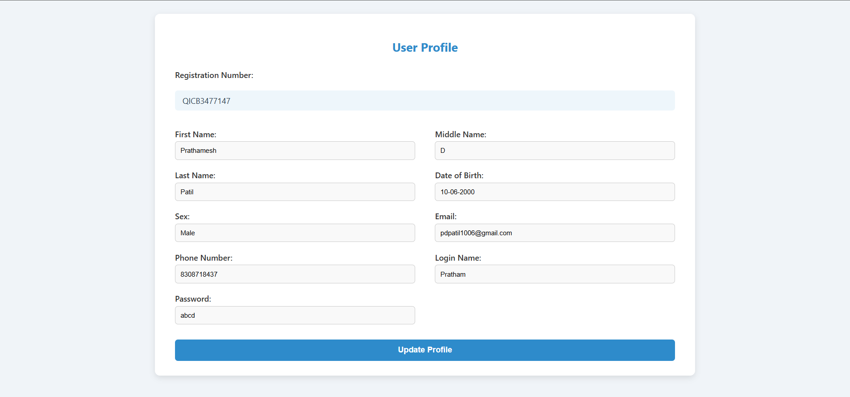

LogoutServlet.java
package com.exam.controller;

import java.io.IOException;

import jakarta.servlet.ServletException;
import jakarta.servlet.http.HttpServlet;
import jakarta.servlet.http.HttpServletRequest;
import jakarta.servlet.http.HttpServletResponse;

public class LogoutServlet extends HttpServlet {
protected void doPost(HttpServletRequest req, HttpServletResponse res) throws ServletException, IOException {
req.getSession().invalidate();
res.sendRedirect("login.jsp");
}
}

DeleteUser.java
package com.exam.controller;

import com.exam.model.UserDAO;

import jakarta.servlet.ServletException;
import jakarta.servlet.annotation.WebServlet;
import jakarta.servlet.http.HttpServlet;
import jakarta.servlet.http.HttpServletRequest;
import jakarta.servlet.http.HttpServletResponse;

import java.io.IOException;

public class DeleteUserServlet extends HttpServlet {
protected void doPost(HttpServletRequest req, HttpServletResponse res) throws ServletException, IOException {
String regNo = req.getParameter("registrationNumber");

UserDAO dao = new UserDAO();
boolean deleted = dao.deleteUserByRegNo(regNo);

if (deleted) {
req.getSession().invalidate(); // Invalidate session after deletion
res.sendRedirect("login.jsp");
} else {
res.sendRedirect("dashboard.jsp?error=delete_failed");
}
}
}

UserDAO.java
package com.exam.model;

import java.sql.*;

public class UserDAO {
private final String url = "jdbc:mysql://localhost:3306/online_exam";
private final String user = "root";
private final String pass = "root";

public Connection getConnection() throws Exception {
Class.forName("com.mysql.cj.jdbc.Driver");
return DriverManager.getConnection(url, user, pass);
}

public boolean registerUser(UserBean u) {
try (Connection con = getConnection()) {
String sql = "INSERT INTO users (registration_number, first_name, middle_name, last_name, dob, sex, email_id, house_number, street, city, state, country, pincode, phone_number, login_name, password) VALUES (?, ?, ?, ?, ?, ?, ?, ?, ?, ?, ?, ?, ?, ?, ?, ?)";

PreparedStatement ps = con.prepareStatement(sql);
ps.setString(1, u.getRegistrationNumber());
ps.setString(2, u.getFirstName());
ps.setString(3, u.getMiddleName());
ps.setString(4, u.getLastName());
ps.setString(5, u.getDOB());
ps.setString(6, u.getSex());
ps.setString(7, u.getEmailID());
ps.setString(8, u.getHouseNumber());
ps.setString(9, u.getStreet());
ps.setString(10, u.getCity());
ps.setString(11, u.getState());
ps.setString(12, u.getCountry());
ps.setString(13, u.getPincode());
ps.setString(14, u.getPhoneNumber());
ps.setString(15, u.getLoginName());
ps.setString(16, u.getPassword());

int i = ps.executeUpdate();
return i > 0;
} catch (Exception e) {
e.printStackTrace();
return false;
}
}

public UserBean validateUser(String regNo, String loginName, String password) {
try (Connection con = getConnection()) {
PreparedStatement ps = con.prepareStatement(
"SELECT * FROM users WHERE registration_number=? AND login_name=? AND password=?"
);
ps.setString(1, regNo);
ps.setString(2, loginName);
ps.setString(3, password);
ResultSet rs = ps.executeQuery();

if (rs.next()) {
UserBean u = new UserBean();
u.setRegistrationNumber(rs.getString("registration_number"));
u.setFirstName(rs.getString("first_name"));
u.setMiddleName(rs.getString("middle_name"));
u.setLastName(rs.getString("last_name"));
u.setDOB(rs.getString("dob"));
u.setSex(rs.getString("sex"));
u.setEmailID(rs.getString("email_id"));
u.setHouseNumber(rs.getString("house_number"));
u.setStreet(rs.getString("street"));
u.setCity(rs.getString("city"));
u.setState(rs.getString("state"));
u.setCountry(rs.getString("country"));
u.setPincode(rs.getString("pincode"));
u.setPhoneNumber(rs.getString("phone_number"));
u.setLoginName(rs.getString("login_name"));
u.setPassword(rs.getString("password"));
return u;
}
} catch (Exception e) {
e.printStackTrace();
}
return null;
}

public boolean deleteUserByRegNo(String regNo) {
try (Connection con = getConnection()) {
PreparedStatement ps = con.prepareStatement("DELETE FROM users WHERE registration_number = ?");
ps.setString(1, regNo);
int i = ps.executeUpdate();
return i > 0;
} catch (Exception e) {
e.printStackTrace();
return false;
}
}

public boolean updateUser(UserBean user) {
try (Connection con = getConnection()) {
PreparedStatement ps = con.prepareStatement(
"UPDATE users SET first_name=?, middle_name=?, last_name=?, dob=?, sex=?, email=?, phone_number=?, login_name=?, password=? WHERE registration_number=?"
);
ps.setString(1, user.getFirstName());
ps.setString(2, user.getMiddleName());
ps.setString(3, user.getLastName());
ps.setString(4, user.getDOB());
ps.setString(5, user.getSex());
ps.setString(6, user.getEmailID());
ps.setString(7, user.getPhoneNumber());
ps.setString(8, user.getLoginName());
ps.setString(9, user.getPassword());
ps.setString(10, user.getRegistrationNumber());

return ps.executeUpdate() > 0;
} catch (Exception e) {
e.printStackTrace();
return false;
}
}

}

UserBean.java
package com.exam.model;

public class UserBean {
private String registrationNumber;
private String firstName;
private String middleName;
private String lastName;
private String DOB;
private String sex;
private String emailID;
private String houseNumber;
private String street;
private String city;
private String state;
private String country;
private String pincode;
private String phoneNumber;
private String loginName;
private String password;

public String getRegistrationNumber() {
return registrationNumber;
}
public void setRegistrationNumber(String registrationNumber) {
this.registrationNumber = registrationNumber;
}

public String getFirstName() {
return firstName;
}
public void setFirstName(String firstName) {
this.firstName = firstName;
}

public String getMiddleName() {
return middleName;
}
public void setMiddleName(String middleName) {
this.middleName = middleName;
}

public String getLastName() {
return lastName;
}
public void setLastName(String lastName) {
this.lastName = lastName;
}

public String getDOB() {
return DOB;
}
public void setDOB(String DOB) {
this.DOB = DOB;
}

public String getSex() {
return sex;
}
public void setSex(String sex) {
this.sex = sex;
}

public String getEmailID() {
return emailID;
}
public void setEmailID(String emailID) {
this.emailID = emailID;
}

public String getHouseNumber() {
return houseNumber;
}
public void setHouseNumber(String houseNumber) {
this.houseNumber = houseNumber;
}

public String getStreet() {
return street;
}
public void setStreet(String street) {
this.street = street;
}

public String getCity() {
return city;
}
public void setCity(String city) {
this.city = city;
}

public String getState() {
return state;
}
public void setState(String state) {
this.state = state;
}

public String getCountry() {
return country;
}
public void setCountry(String country) {
this.country = country;
}

public String getPincode() {
return pincode;
}
public void setPincode(String pincode) {
this.pincode = pincode;
}

public String getPhoneNumber() {
return phoneNumber;
}
public void setPhoneNumber(String phoneNumber) {
this.phoneNumber = phoneNumber;
}

public String getLoginName() {
return loginName;
}
public void setLoginName(String loginName) {
this.loginName = loginName;
}

public String getPassword() {
return password;
}
public void setPassword(String password) {
this.password = password;
}
}

